Power BI Dashboard Samples  
  
  
1. Bank Loan US Report   
  
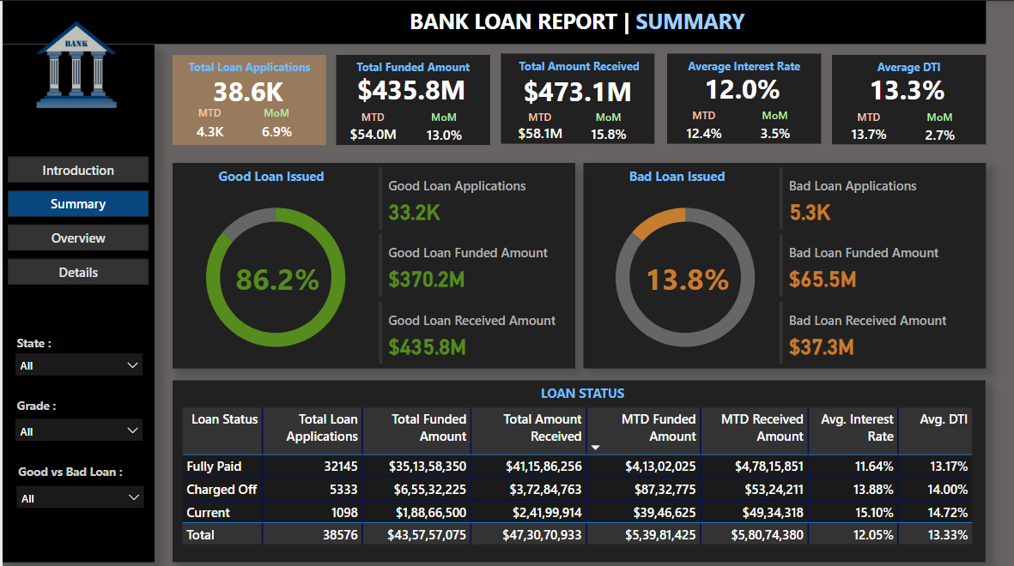  
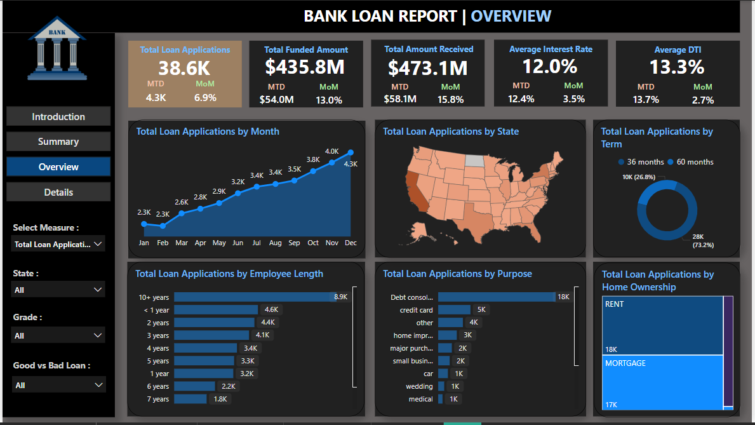

2. Rainfall Data Dashboard   
  
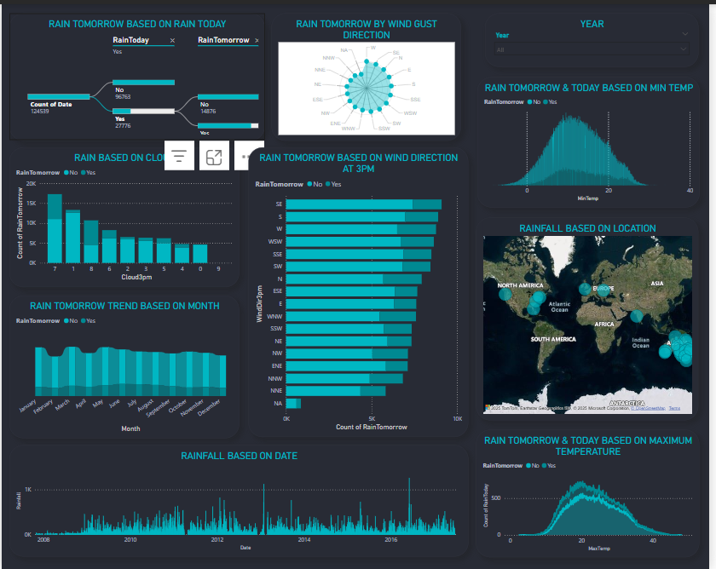  
  
  
3. Global Terrorism Data Visualization  
  
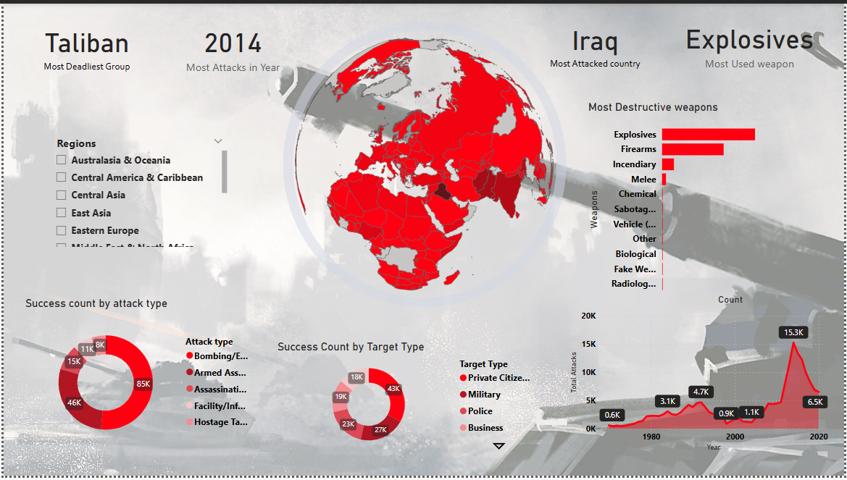

4. US healthcare Data Report  
  
